# Project Name: Online Test Application.

## GitHub Link:

<https://github.com/tamasjit/myjavaproject/tree/master/Phase%204/Phase-4_Assesment/q1_onliequiz>

### Landing page:

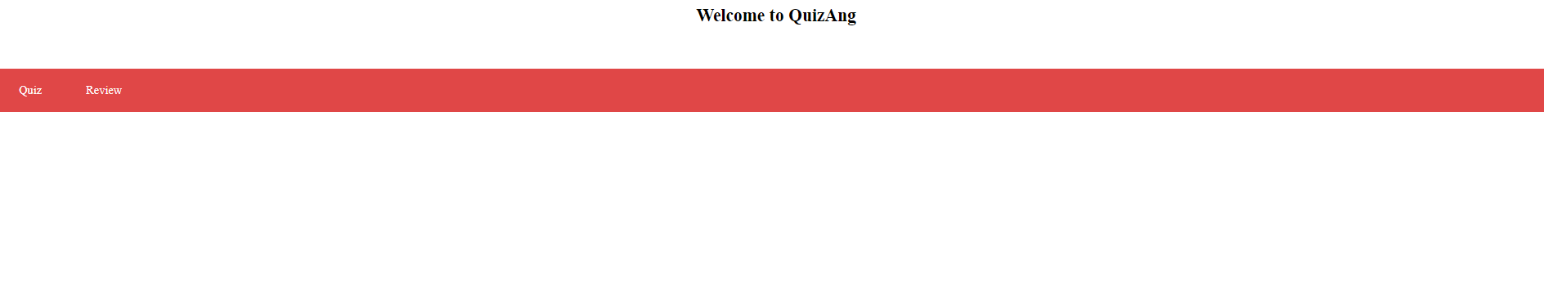

### Quiz Page:

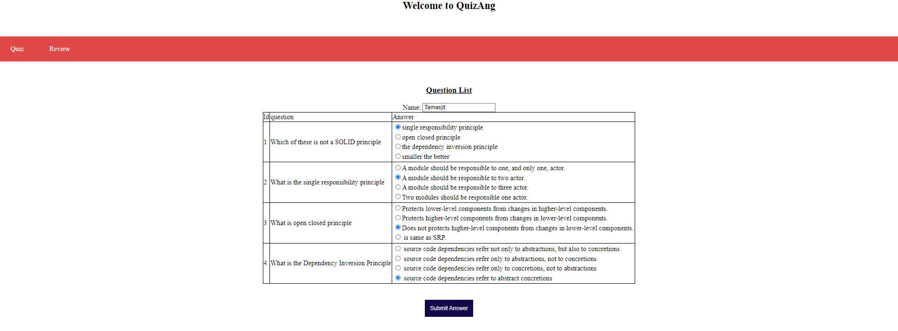

### Review of given Ans:

### Review Page:

